#### **Conclusion**

Now you have gained the skills of a Professional Vulnerability Assessor. In summary, these are the topics you have learnt in this course:

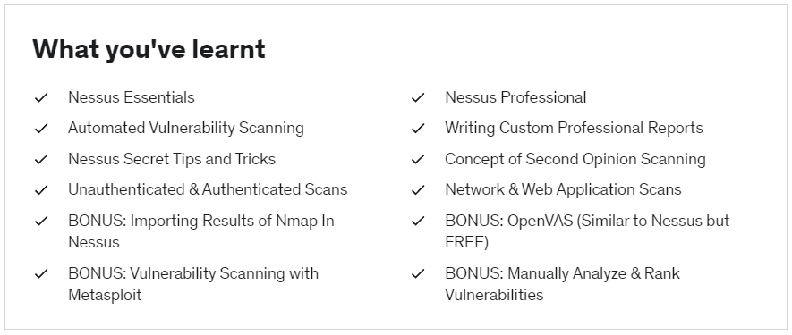

I sincerely hope that you have got what you were looking for in this course.

This is like a Journey you completed. Maybe you asked questions, felt excited at times about learning something new, acquired knowledge of reporting, overcomed your overwhelmness and much more.

#### **Congratulations**

On completing this course and having learnt Vulnerability Assessment from Basic to Advanced Level.

If you are on your **browser**, and have completed all the lectures, you may now take your ***certificate of completion*** for this course, by clicking on the "Get Certificate" button on top right of the screen.

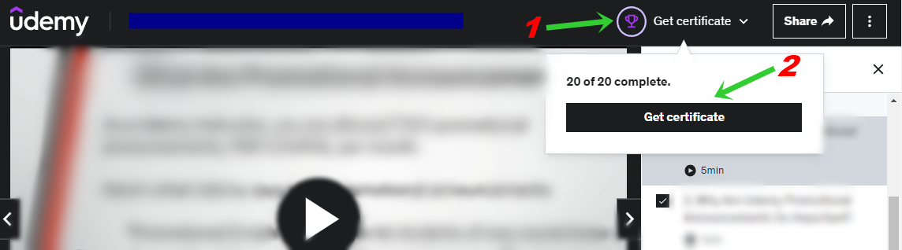

(OR)

If you are on the **Udemy’s mobile app**, and have completed all the lectures, you may now take your ***certificate of completion*** for this course, by tapping More and then Course Certificate.

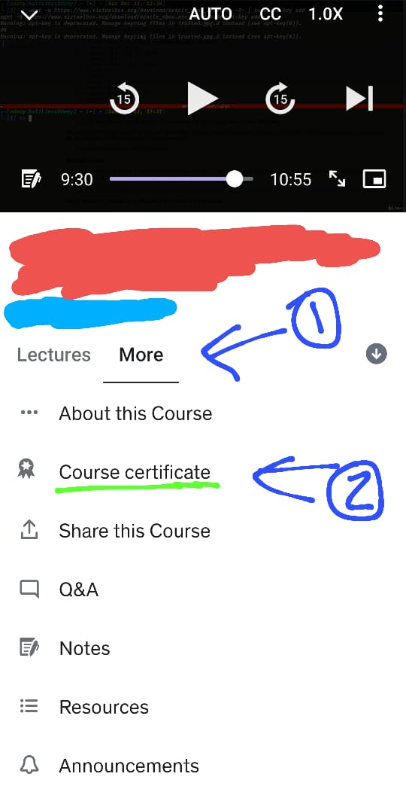

You can put this certificate on your LinkedIn profile, CV, Resume, etc. This is NOT a random skill or course which you would want to ignore. Trust me, this will be a very helpful thing to have in all those places. So, I hope you will add it your profile.

#### **Thank You**

For investing your money and time in such a course that helps you develop one of the most important skills of cyber security – Vulnerability Assessment. I appreciate every minute you have spent with me here in this course.

If you enjoyed this course, I would be really happy if you could leave a **REVIEW** to this course, to help other students decide whether they want to take this course or not.

And just keep learning new things daily, my friend. Adding such small-small values slowly and continuously to your skillset, you will become an expert one day... soon.

Sincerely,

~ Avinash Yadav